Data standardization protocol for Covid-19 technological solutions as an information source for open innovation

Protocolo de padronização de dados para soluções tecnológicas de Covid-19 como fonte de informação para inovação aberta

Protocolo de estandarización de datos para soluciones tecnológicas frente a la COVID-19 como fuente de información para la innovación abierta

Como citar:
Santos, André L. M., Costa, Priscila R., Arantes, Camila N. & Marson, Celise. (2026). Data standardization protocol for Covid-19 technological solutions as an information source for open innovation. Revista Gestão & Tecnologia, vol. 26, n⁰ 3, p. 156-184

André Luis Marques Ferreira dos Santos, Doutor em Informática e Gestão do Conhecimento, e Mestre em Engenharia da Produção, UNINOVE.
andrelmfsantos@gmail.com https://orcid.org/0000-0002-5232-0781

Priscila Rezende da Costa, Professora Titular da ESPM, atuando no Programa de Pós-Graduação em Administração
priscilarezende@yahoo.com.br https://orcid.org/0000-0002-7012-0679

Camila Naves Arantes, Doutor em Administração de Empresas (UNINOVE) cursando MBA em Gestão da Transformação Digital na USP.
camilanarantes@gmail.com https://orcid.org/0000-0002-4072-8624

Celise Marson, Mestre em Administração de Empresas, UNINOVE. Atua no Programa de Pós-Graduação em Direito (Stricto Sensu) da UNINOVE
marsoncelise@gmail.com https://orcid.org/0009-0005-5471-5911

Os autores declaram não haver qualquer conflito de interesse de natureza pessoal ou corporativa, em relação ao tema, processo e resultado da pesquisa.

Editor in chief: José Edson Lara
Organization Scientific CommitteeDouble Blind Review by SEER/OJS
Received on 07/11/2025
Approved on 03/07/2026

This work is licensed under a Creative Commons Attribution – Non-Commercial 3.0 Brazil
Abstract
Objective: The study proposes a protocol for the standardization of databases of technological solutions related to COVID-19, aiming to improve interoperability, transparency, and the use of these data as an information source for open innovation.

Methodology: A protocol was developed that defines standardized data formats, inclusion and exclusion criteria, and interoperability guidelines, applied to INPADOC (International Patent Documentation) data. Use cases were analyzed to assess the impact of standardization on the aggregation and sharing of technological information.

Originality: The research contributes by proposing a structured and replicable model for the integration of technological data, addressing the lack of uniform standards that hinder comparison and international cooperation in health crisis contexts.

Main results: The application of the protocol showed significant improvements in data interoperability and aggregation, strengthening interinstitutional and international collaboration. It also revealed the potential for discovering new technological routes and enhancing strategies for responding to health emergencies.

Theoretical contributions: The study broadens the debate on data management in global crises by demonstrating that the standardization of technological databases is an essential condition for the effectiveness of open innovation and for scientific advancement in public health and technology.

Keywords: COVID-19 technological solutions. Patent. Protocol. Database standardization. Information source. Open innovation.

Resumo
Objetivo: O estudo propõe um protocolo para padronização de bancos de dados de soluções tecnológicas relacionadas à COVID-19, visando aprimorar a interoperabilidade, a transparência e o uso desses dados como fonte de informação para a inovação aberta.

Metodologia: Foi desenvolvido um protocolo que define formatos normalizados de dados, critérios de inclusão e exclusão e diretrizes de interoperabilidade, aplicado aos dados do INPADOC (International Patent Documentation). Casos de uso foram analisados para avaliar o impacto da padronização sobre a agregação e o compartilhamento das informações tecnológicas.

Originalidade: A pesquisa contribui ao propor um modelo estruturado e replicável de integração de dados tecnológicos, respondendo à ausência de padrões uniformes que dificultam comparações e cooperação internacional em contextos de crise sanitária.
Principais resultados: A aplicação do protocolo mostrou ganhos significativos na interoperabilidade e na agregação dos dados, fortalecendo a colaboração interinstitucional e internacional. Observou-se ainda o potencial de descoberta de novas rotas tecnológicas e aprimoramento das estratégias de resposta a emergências sanitárias.

Contribuições teóricas: O estudo amplia o debate sobre a gestão de dados em crises globais ao demonstrar que a padronização dos bancos de dados tecnológicos é condição essencial para a eficácia da inovação aberta e para o avanço científico em saúde pública e tecnologia.

Palavras-chave: Soluções tecnológicas da Covid-19. Patente. Protocolo. Padronização de banco de dados. Fonte de informação. Inovação aberta.

Resumen
Objetivo: El estudio propone un protocolo para la estandarización de bases de datos de soluciones tecnológicas relacionadas con la COVID-19, con el objetivo de mejorar la interoperabilidad, la transparencia y el uso de estos datos como fuente de información para la innovación abierta.

Metodología: Se desarrolló un protocolo que define formatos de datos estandarizados, criterios de inclusión y exclusión, y directrices de interoperabilidad, aplicado a los datos del INPADOC (International Patent Documentation). Se analizaron casos de uso para evaluar el impacto de la estandarización en la agregación y el intercambio de información tecnológica.

Originalidad: La investigación contribuye al proponer un modelo estructurado y replicable para la integración de datos tecnológicos, abordando la falta de normas uniformes que dificultan la comparación y la cooperación internacional en contextos de crisis sanitaria.

Principales resultados: La aplicación del protocolo mostró mejoras significativas en la interoperabilidad y la agregación de los datos, fortaleciendo la colaboración interinstitucional e internacional. También se evidenció el potencial para descubrir nuevas rutas tecnológicas y mejorar las estrategias de respuesta ante emergencias sanitarias.

Contribuciones teóricas: El estudio amplía el debate sobre la gestión de datos en crisis globales al demostrar que la estandarización de las bases de datos tecnológicas es una condición esencial para la eficacia de la innovación abierta y para el avance científico en salud pública y tecnología.

Palabras clave: Soluciones tecnológicas de la COVID-19. Patente. Protocolo. Estandarización de bases de datos. Fuente de información. Innovación abierta.

1 Introduction
There has been a growing increase in the amount of data available for analysis across various technological fields, with patent data analysis standing out as a valuable source of information. Technological advancements have led to both challenges and an increasing need to manage the content of knowledge bases (Abbas et al., 2014).
Patent data are extensive, and organizations use them in multiple ways — for example, to verify patent novelty, analyze technological trends and developments, extract information, identify technological routes, or explore promising innovations (Abbas et al., 2014). Thus, it is undeniable that patents are valuable sources of information related to technical innovations (Abraham & Moitra, 2001; Zotan & Audretsch, 1989; Janavi & Emami, 2020).
However, the analysis of these documents — which involve large volumes of data (Zhang & Liu, 2020) — requires intelligent tools capable of retrieving and representing information clearly (Abbas et al., 2014). Such documents consist of structured and unstructured data: the former refers to consistent and standardized data (such as patent number, filing date, IPC classification, cited patents, assignees, and inventors), while the latter includes descriptive texts (title, abstract, claims, and description) (Zhang & Liu, 2020).
When extracting patent data from different intellectual property offices, one often encounters an immense amount of information that is commonly unstandardized, especially the structured data. The lack of standardization hinders the understanding of relevant insights that patents may provide. Therefore, discussing the management and standardization of patent data is essential to optimize information analysis and facilitate the integration of diverse sources, ensuring a reliable tool.
Data standardization facilitates the integration of different information sources, improves analytical accuracy, and supports strategic decision-making in companies, research institutions, and government agencies. Considering the context of challenges and the need for rapid action — as observed during the COVID-19 pandemic crisis — this study aims to propose a protocol for the processing and standardization of technological data on patent-based solutions, focusing on this infection as a source of information for open innovation.
Developing a standardized database protocol is a critical challenge, as it involves harmonizing heterogeneous and often inconsistent data that may vary in format, quality, and origin. Standardization is essential to ensure interoperability among different systems, yet the diversity of schemas and the lack of consensus on standards can lead to the loss of valuable information and difficulties in integration (Batini & Scannapieco, 2016). Furthermore, automating this process is complex and requires advanced techniques to address ambiguities and inconsistencies inherent to the data (Doan, Halevy & Ives, 2012).
Structuring a standardized database of COVID-19 technological solutions plays an important role in promoting open innovation, especially in global health crisis contexts. Such a database not only consolidates the developed technical and scientific knowledge but also facilitates access to and dissemination of critical information among researchers, companies, and public institutions. By centralizing this knowledge, it becomes possible to accelerate the development of new technologies, avoid duplication of efforts, and foster collaborations that may lead to faster and more effective innovations in combating the pandemic. As highlighted by Liu et al. (2022), the accessibility and transparency of patent data are essential to maximize the impact of research and development in health emergency scenarios, as they allow for broader and more integrated analyses of available technologies, enhancing their practical application in addressing emerging challenges.

2 Theoretical framework
COVID-19 was the first contemporary disease to generate an extensive amount of accumulated data, resulting in a valuable source of information (Biancolella et al., 2023). Promoting open innovation is essential for crisis management, as it mobilizes technologies and resources to rapidly develop innovations (Onyango & Ondiek, 2022). By enabling research processes, data sharing is crucial for an effective pandemic response (Ritto et al., 2024); thus, the development of methodologies that allow the creation of new databases becomes essential.
Patents are documents that describe inventions (Noh & Lee, 2020), and within cooperative innovation networks, they can reduce R&D costs, promote resource sharing, and facilitate technology diffusion (Jialu et al., 2021). There is a strong relationship between patent data and open innovation analysis (Cammarano et al., 2022). When open innovation is supported by governmental policies, innovations are developed more rapidly and effectively (Patrucco et al., 2022). During the pandemic, countries that adopted open innovation generated a greater number of innovations, with collaborative platforms proving to be effective tools for promoting accelerated innovation in times of crisis (Patrucco et al., 2022).
The patent system grants inventors temporary rights over their creations, protecting them from copying and allowing the disclosure of their inventions (Holgersson & Granstrand, 2017). As intangible assets, patents provide inventors with market exclusivity, which gives them significant commercial value (Liu et al., 2022). In the context of open innovation, patent data metrics become even more relevant for measuring R&D productivity, as firms tend to place higher value on patenting within open arrangements (Holgersson & Granstrand, 2017). For innovative companies, patents act as facilitators of open innovation (Holgersson & Granstrand, 2017).
Open innovation has the potential to accelerate innovation efforts during crises (Chesbrough, 2020). The lessons learned from this process are valuable for managing innovation even after the crisis ends. Therefore, studying the impact of open innovation in relation to patents is fundamental to understanding firm performance, minimizing resource waste, and supporting the value they create (Patra, 2023). Patent citation can be used to explore the flow and sharing of knowledge within open innovation, although it remains challenging to establish clear standards for this analysis (Suh & Jeon, 2019). Open innovation involves the ability to connect with diverse external agents as sources and opportunities for innovation (Suh & Jeon, 2019), making it necessary to deepen the analysis of patent documents to better understand this process.
There is a positive relationship between the openness of processes for open innovation and innovation capacity (Capone & Innocenti, 2020). However, it is not the number of collaborations that fosters innovation, but rather the quality of those collaborations (Capone & Innocenti, 2020). Furthermore, there is a positive correlation between the quality of scientific publications and the number of patents, making patents important indicators in the promotion of innovation (Liu et al., 2022). Patent analysis includes understanding the relationships between various indicators, such as social networks, which can represent network connections or cluster density (Borgatti et al., 2009; Liu et al., 2022).
Even with advances in digitization and the availability of patent data, there are still significant challenges in organizing and harmonizing this information. Initiatives such as the creation of unified dashboards and databases are essential to overcome these barriers and provide a comprehensive and integrated view of patent activity. Thus, the creative and open management of intellectual property, combined with the sharing of experiments by scientists (Chesbrough, 2020), reinforces the relevance and justification of this study.

3 Method
The database of technological solutions for COVID-19 was composed of patents collected from the Derwent Innovation platform, specifically INPADOC, which consolidates patent information from various offices around the world. The period considered was from January 1, 2020, to December 31, 2022. The search strategy used was: ("COVID*" OR "coronavirus disease 2019" OR "coronavirus pneumonia" OR "novel coronavirus disease" OR "COVID" OR "COVID disease" OR "COVID virus" OR "coronavirus pandemic" OR "SARS-CoV-2" OR "coronavirus 2" OR "novel coronavirus" OR "COVID virus" OR "SARS2" OR "Wuhan coronavirus"). Data were extracted in table format, with a maximum of 60,000 INPADOCs per table.
Data collection from the Derwent Innovation platform was carried out to ensure the comprehensiveness and representativeness of the database regarding technological solutions for COVID-19. The choice of this platform is justified by its high level of standardization and the depth of its patent data when compared to other free databases. Moreover, it provides robust functionalities for searching, filtering, and analyzing data, and—most relevant to this study—it offers broad global coverage of patent documents, often more extensive and up to date than other databases (Clarivate, 2023). The use of INPADOCs, which are patent families, enables a more robust analysis by considering geographical and temporal variations in filings, thereby expanding the perspective on technological development throughout the pandemic. This approach ensures that the analysis includes not only patents filed in different countries but also those developed in diverse contexts and emergency situations.
Scientometric studies based on patents serve as data sources to explore the current state of the art in a given technological field. According to the European Patent Convention, the state of the art encompasses all knowledge or technology related to a given innovation, made public in written or oral form, through use, or by any other means, prior to the filing of a patent (Hirata et al., 2015).
To facilitate data processing and analysis, extraction was performed in table format. This data structure enables the application of advanced techniques such as data mining, network analysis, and technological route mapping—essential for identifying patterns, trends, and gaps in innovations related to COVID-19. Additionally, the tabular format facilitates research replicability, ensuring that results can be validated by future studies and providing greater consistency to scientific findings.
It is important to highlight that a patent document provides the necessary description for reproducing what is being patented, as well as information on patent families, prior knowledge, geographical applications, among other indicators. Furthermore, the acceptance of a patent is conditioned upon the establishment of the state of the art—that is, the search for prior art related to a given invention must ensure its novelty (Masiakowski & Wang, 2013; Quoniam et al., 2014). Therefore, patent filings must precede even scientific articles describing the knowledge underlying the invention.
In this study, data science techniques were adopted for the development of the protocol. Initially, a survey and critical analysis of the main standards and frameworks existing in biomedical databases and information management systems were conducted to identify gaps and opportunities for standardization.
Subsequently, data modeling and ontology techniques were applied to structure the protocol, ensuring interoperability and compliance with health system requirements. The protocol was validated through an experimental case study using a real database on technological solutions for COVID-19, in which efficiency, consistency, and scalability criteria were applied to evaluate the effectiveness of the proposed protocol. Finally, the protocol development steps were thoroughly documented to ensure replicability and adaptability in different public health contexts.

4 Results

The following subsections propose and detail the stages of the standardization protocol for the COVID-19 technological solutions database as an information source for open innovation. It is worth emphasizing that open innovation, a concept introduced by Chesbrough (2006), refers to the generation and utilization of ideas both internal and external to organizations. This concept emerged as an essential competitive strategy in certain sectors, including information technology (Dodgson et al., 2006; Zien & Buckler, 2003).

The protocol’s stages enable standardized and structured manipulation of the database, establishing a systematic foundation for future analyses and studies on collaboration networks and technological routes based on patent data. The following sections describe these stages in detail.

4.1 Configurations and tools used for data manipulation from the Derwent database and computational environment

For the manipulation of the original Derwent database, a computer with the following specifications was used: Operating System Ubuntu 24.04 LTS, 64-bit System Type, Acer Aspire A515-57 model, 12th Gen Intel Core i5-12450H x12 processor, 16.0 GiB memory, and Intel Graphics (ADL GT2).
The programming language selected was Python (Python Software Foundation, 2023), with the Pandas library (McKinney, 2010) for data manipulation. The integrated development environment (IDE) used was Jupyter Notebook (Kluyver et al., 2016), which provides an intuitive interface combining code, text, visualizations, and interactive elements.
Jupyter Notebook is an ideal tool for data science tasks, as it combines report text with executable code, facilitating the publication of reproducible research (Kluyver et al., 2016). Although the format alone does not guarantee reproducibility (Pimentel et al., 2019), documenting processes with results is extremely valuable for this purpose. Its format facilitates exploratory data analysis (Perkel, 2018), which has made it the most widely used system for interactive literate programming (Shen, 2014). Because of its use in experiments and data analysis, Jupyter notebooks must be reproducible and made available on open platforms for consultation and replication of experiments (Perkel, 2021).

4.2 Data division and preparation
In Data Science, data quality is essential for validating research, significant discoveries, and machine learning models. However, raw data are often incomplete, noisy, inconsistent, and sometimes in unsuitable formats. Therefore, before being used in models and other research stages, it is crucial to verify data integrity and identify potential issues—a process known as data preprocessing. Preparing data means adapting them for research processes using preprocessing techniques that include Data Cleaning, Data Integration, Data Transformation, and Data Reduction (Pimentel et al., 2021).
Data Cleaning removes noise and corrects inconsistencies; Data Integration combines data from multiple sources into a coherent repository; Data Transformations, such as normalization, improve the accuracy and efficiency of algorithms involving distance measurements; and Data Reduction decreases data volume by eliminating redundant features. This section describes these technical stages using examples based on real data (Pimentel et al., 2021).
To mitigate performance issues during processing, the initial step involved segmenting the original Derwent patent file. This file, in .xlsx format, contained 126 variables and 18,424 predominantly textual observations. To facilitate data handling, it was divided into 40 smaller files in .csv format. This approach was essential due to the substantial size of the database. Moreover, the limitations of the available equipment made it unfeasible to process and treat the file in its entirety at once. For online availability, files up to 20 MB were chosen, a restriction imposed by the platform used (GitHub), which does not support uploads exceeding this file size limit.
The smaller files, once made available online, fully represent the original database and allow the use of lower-capacity hardware for future operations. The system used in this stage was an Acer Aspire A515-57 computer with Ubuntu 24.04 LTS Operating System, 64-bit type, 12th Generation Intel Core i5-12450H processor, 16 GB RAM, and Intel Graphics (ADL GT2). This configuration enabled efficient and cost-effective data manipulation.

4.2.1 Development and implementation of data manipulation scripts
During the standardization process, three essential computer programs (scripts) were developed for database manipulation.
The first script aimed to divide the original patent file into 40 smaller .csv files, a crucial step for efficiently managing the volume and complexity of the data (Figure 1).

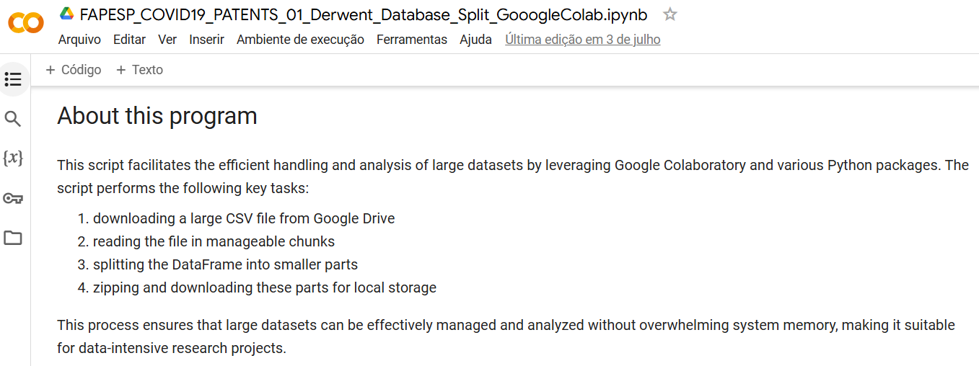
Figure 1- Division of the patent file

The second script was developed to extract and standardize the names of entities listed in the “Optimized Assignee” column. This process involved normalizing the names to eliminate inconsistencies and remove duplicate values, thereby optimizing the quality and usability of the data (Figure 2).

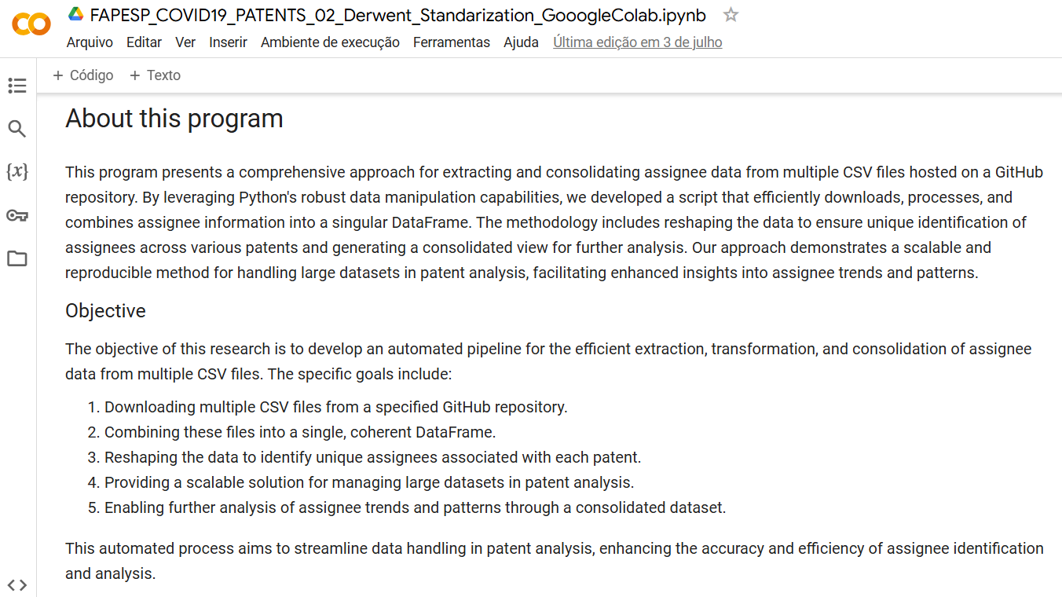
Figure 2 - Extraction and standardization of entity names

Finally, the third script was used to create supporting variables (IDs) and integrate the original Derwent database with the newly normalized data, resulting in a unified database. This script played a key role in synthesizing the processed data, enabling more robust and integrated analyses. Collectively, the set of scripts significantly improved the handling, access, and analysis of patent data (Figure 3).

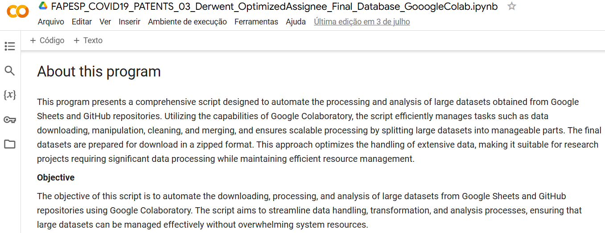
Figure 3 - Data integration

Additionally, the first script performed a crucial supplementary function: the development of a variable dictionary that documents the initial characteristics of the database. Using the Python Pandas library, two key pieces of information were detailed for each variable: (1) a representative expression of the variable name and (2) the data type it stores. To further enrich the dictionary, these details were complemented with comprehensive descriptions of each variable extracted from a document provided by Derwent. The third column of the dictionary provides a deeper understanding of the information contained in the database, facilitating its interpretation and use by other researchers.

4.2.2 Creation of the Variable Dictionary
The first script enabled the creation of a variable dictionary. For this purpose, the Pandas library was used, whose name derives from the English term Panel Data. Developed for the Python programming language, Pandas is widely used by data scientists because it offers high-performance data structures and tools for analyzing tabular and time series data, in addition to being easy to use (Paskhaver, 2021). Accordingly, the following information was extracted for each variable: (1) a standardized representative name and (2) its data type. These details were then supplemented with information from the Derwent document, adding a third column containing the description of each variable in the database.
The variable dictionary is a valuable tool for anyone working with the database, as it provides a clear view of the available variables and their characteristics. To ensure open and easy access, it is available for consultation in the data repository on GitHub, thereby facilitating collaboration and the advancement of new research (Figure 4).

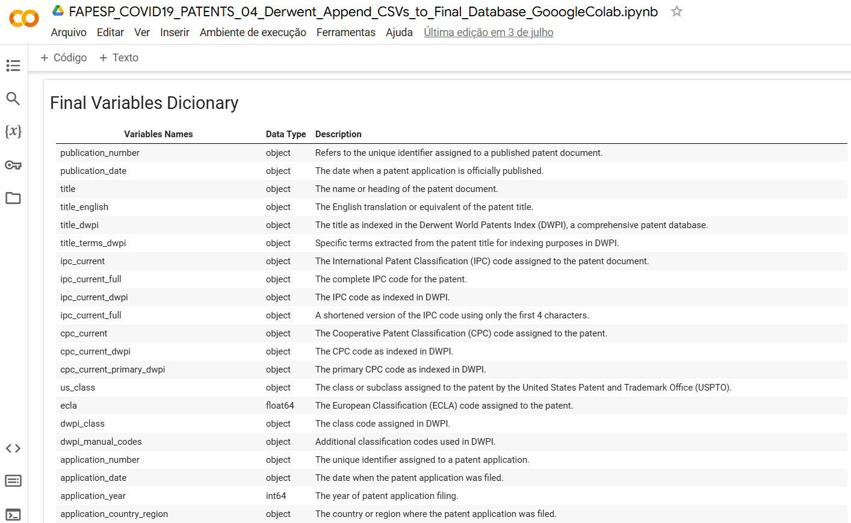
Figure 4 - Variable Dictionary

4.2.3 Standardization and Classification of Entities in the Database
The second developed script focused on standardizing the names of entities in the “optimized assignee” column of the database. This standardization was necessary due to the observation that the same entity could appear under different names in various records. For instance, the entity “UNIV FEDERAL DO PARANA” appeared in one record, while “UNIV FEDERAL DO PARANA UFPR” appeared in another, even though both referred to the same educational institution.
In addition to unifying the names, the script also introduced new variables (columns) to facilitate the identification of the nature of each entity, whether it was an organization or an individual. To enrich this classification, the process was based on the Open Innovation Theory, which allows entities to be categorized as: (a) universities and research institutes, (b) private companies, (c) government agencies, and(d) individuals (Chesbrough, 2003).
This classification is crucial for enabling more segmented future analyses. For example, the processed database can be filtered to select only specific types of entities, facilitating targeted studies such as analyzing networks of innovative collaboration that focus exclusively on organizations while excluding individuals. This process not only improves analytical precision but also increases the database’s usefulness for a broader range of investigations.
At the beginning of the standardization process, 15,065 entity names were identified in the original Derwent database. After implementing the standardization process, this number was reduced to 14,721 unique entities, eliminating 344 duplicates. However, it is possible that the number of duplicate entities could still be further reduced.
The database contains a significant number of individuals, and due to the absence of additional fields (such as ID numbers), precise identification of duplicates is challenging. For example, “Zhang Wei” and “Zhang Weiwei” were kept as separate records, since there was insufficient evidence to confirm whether they referred to the same person. Only in cases where differences in names were clearly attributable to typographical errors—such as between “ZAKI GEORGE ABDEL MESSIH” and “ZAKI GEORGE ABDELMESSIH” (in which the second name simply omits a space between “Abdel” and “Messih”)—was standardization performed. This conservative approach ensures data integrity by preventing the erroneous merging of records belonging to different individuals, thereby preserving the accuracy and reliability of the database for future queries.
Additionally, unique identifiers were developed for each standardized entity. This strategy was implemented to facilitate result interpretation across various analyses. By introducing the variable “optimized_id,” data presentation in tables, graphs, and diagrams was simplified—especially when entity names were lengthy. For example, instead of using the full name “TEKSMER EGITIM DANISMANLIK ARASTIRMA VE LABORATUVAR HIZMETLERI ANONIM SIRKETI,” the identifier “id_12318” was used.
Moreover, a variation of these unique identifiers was created by replacing the “id” suffix with a suffix reflecting the classification based on Open Innovation Theory. In the example mentioned, the identifier was adapted to “med_690,” where “med” indicates that the entity belongs to the category of medical units (such as laboratories and hospitals), and the number “690” designates that this entity is the six hundred and ninetieth of that type.
This identification methodology not only enhances the visual and organizational clarity of the data but also provides a coherent structure that facilitates detailed and specific analyses, allowing researchers to efficiently filter and examine data subsets. To optimize collaboration network analyses and future studies, a new column was implemented in the database assigning a unique identifier (ID) to each party involved. Furthermore, standardized entities were classified following a hierarchical structure based on the Open Innovation Theory. The categories were defined as detailed in Table 1.

Table 1
Distribution of standardized assignees (entities) based on Open Innovation Theory

CATEGORY | SUFFIX | CLASS RANGE
University – Universities/research institutions: Top priority was given to these institutions, recognizing their central role in research and development activities. | uni | 1 até 1.134
Research Institutions – Research institutions: Organizations dedicated to conducting scientific and technological research. | res | 1 até 688
Laboratory, Medical Center, Hospital – Medical units: Includes laboratories, medical centers, and hospitals, recognizing their importance in innovation, especially in applied and clinical research contexts. | med | 1 até 790
Company – Private companies: Commercial entities that do not fit into the first three categories but play a significant role in innovation are classified here. | com | 1 até 4.634
Government – Government bodies: This category encompasses entities ranging from military institutions to other government agencies involved in research and development activities. | gov | 1 até 44
Individual – Individuals: Researchers and inventors acting in an individual capacity. | ind | 1 até 7.423
Not Identify – Not Identify | ni | 1
Anonymous – Anonymous | ano | 1 até 7

The application of this hierarchy ensures that, in cases where an entity could fit into multiple categories, it is classified according to the established priority. For example, if an entity can be identified both as an educational institution and as a government institution, it will be classified as an educational institution. Likewise, an entity operating as a private company but not fitting into higher-priority categories will be classified solely as a private company. This classification methodology prevents duplication and highlights the importance of universities and research institutes within the context of open innovation. Consequently, it allows for more precise and structured analyses capable of revealing significant insights into how different entities collaborate and contribute to the innovation ecosystem.

The standardization process resulted in the addition of several columns to the original Derwent database: “Optimized ID,” a unique identifier for each standardized entity name; “Open Innovation ID,” a unique identifier for each standardized name based on Open Innovation Theory; and “Optimized Assignee Standardized,” which represents the standardized version of the “Optimized Assignee” variable.

After standardization, missing data in the “Optimized Assignee” field were removed. From a total of 18,424 observations, 98 records were excluded, resulting in 18,326 records in the final database. Missing assignee fields may occur for several reasons, including data entry errors, pending assignments, confidentiality, data privacy regulations, source limitations, technical issues, intentional omissions, or delays in data processing (BitLaw, 2024; Sperry & Hammond, 2020; Burgy & Berkowitz, 2013).

4.2.4 Reintegration of Standardized Names and IDs into the Original Database
After completing the standardization process of entity names, the standardized names and IDs were reintegrated into the original database. This was done by creating a new column that organizes standardized names into lists, with each list representing a vector associated with the same patent publication number. This organized structure enables a clear visualization of the connections among entities linked to each patent publication, facilitating the analysis of how collaboration networks are formed within the patent landscape.
The new column containing standardized names becomes a valuable tool for future research, allowing scholars to gain deeper insights into collaboration dynamics and the interactions among entities involved in technological innovation. This approach not only improves data management but also enriches analytical possibilities using this structured database.
After adding the new variables to the original Derwent dataset, missing data in the “Optimized Assignee” field were once again removed. Initially, the database contained 18,424 patent records. After removing missing data, 18,326 records remained—meaning 98 records, or approximately 0.5% of the original dataset, were excluded.
There are multiple reasons for missing assignee data in patent applications, including:
a) Data entry errors: simple human mistakes in filling out forms can result in blank fields.
b) Not applicable: in some cases, no assignee is involved or identifiable at the time of filing, such as when the patent is requested by an individual inventor who retains ownership rights.
c) Pending assignment: if the patent application is still under review and the assignee has not yet been determined, the field may initially be left blank.
d) Public domain: if a patent enters the public domain, there will be no assignee since the invention is no longer protected by intellectual property rights.
e) Confidentiality: in certain cases, assignee information may be withheld to protect trade secrets or strategically sensitive information.
f) Data privacy regulations: depending on jurisdiction and applicable privacy laws, assignee information may be intentionally omitted.
g) Data source limitations: the data source may be incomplete or outdated, resulting in missing fields.
h) Technical issues: system errors in patent application management platforms can lead to unfilled fields.
i) Intentional omission: in rare cases, the assignee field may be intentionally left blank to avoid disclosing sensitive information or to preserve anonymity for strategic reasons.
j) Data processing delays: assignee information may not be immediately available or updated due to processing or synchronization delays among databases or systems.

The reasons for missing assignee data in patent applications are based on general principles of patent administration and can be found in technical and legal references such as the Manual of Patent Examining Procedure (MPEP) and specialized patent law websites (BitLaw, USPTO, Mintz, Finnegan). These explanations encompass human, technical, and legal factors, providing a comprehensive understanding of why missing fields may occur in patent databases.
Finally, figure 5 presents a detailed flowchart of the process for creating the standardized and unified database. This diagram illustrates each methodological step—from the initial data segmentation to the final integration of standardized identifiers—offering a clear and structured view of the workflow adopted.

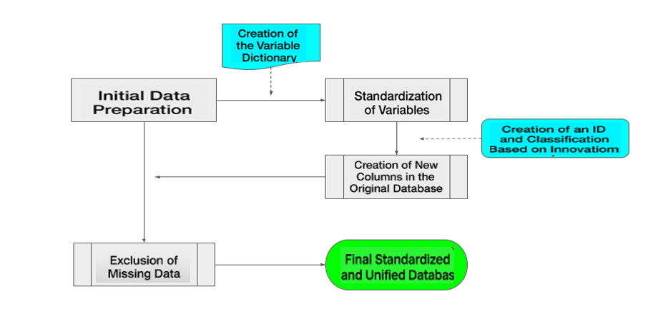
Figure 5: Flowchart for the creation of the standardized and unified database

4.2.5 Presentation of the standardized database and main statistics
Through the execution of the developed scripts, the original database was subdivided, standardized, and integrated, resulting in a more manageable and cohesive structure. The standardization of entity names reduced the initial number from 15,065 to 14,721 unique entities, eliminating 344 duplicates. This process was essential to ensure data consistency and to facilitate future analyses. The introduction of unique identifiers (“optimized_id” and “Open Innovation ID”) simplified data presentation, allowing for a clear and organized visualization of the information (Figure 6).

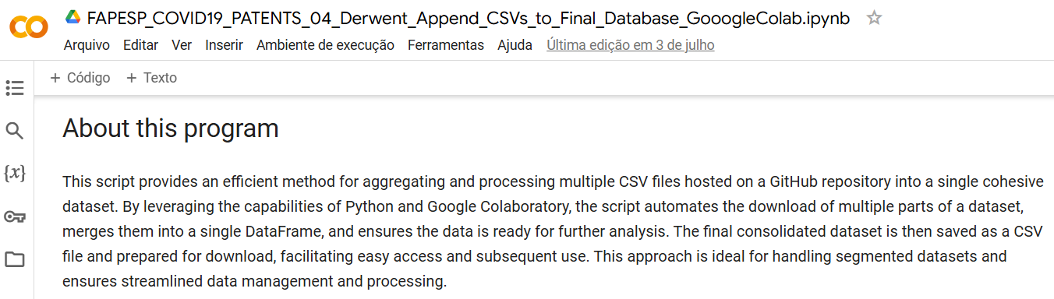
Figure 6: Integration and standardization of data

The implementation of the variable dictionary was an important step in providing a clear and structured view of the variables contained in the database. Using the Pandas library, standardized names and data types were extracted and complemented with detailed descriptions of each variable. This dictionary, available in the GitHub repository, facilitates understanding and use of the database by researchers, promoting collaboration and the advancement of new studies.
The classification of entities according to Open Innovation Theory enabled a detailed segmentation of the different categories present in the database. These categories were defined as Universities, Research Institutions, Medical Units, Private Companies, Government Bodies, and Individuals. This classification is essential for segmented analyses, allowing specific studies on innovative collaboration among different types of entities. Applying this hierarchy ensured proper prioritization and categorization of entities, preventing duplications and emphasizing the importance of universities and research institutes.
Data cleaning in the “Optimized Assignee” field resulted in the exclusion of 98 records out of a total of 18,424, leading to a final dataset of 18,326 records. This process ensured that the database was free from inconsistencies and ready for accurate analyses. The reasons for missing data were diverse, including input errors, pending assignments, confidentiality, and data privacy regulations. This cleaning stage was fundamental to guarantee the integrity and reliability of the data.
The reintegration of standardized names and IDs into the original database, through the creation of a new column, enabled a clear visualization of the connections among entities related to each patent publication. This organized structure facilitated the analysis of collaboration networks, providing valuable insights into interactions among different entities in the development of technological innovations.

4.3 Experimental Case: Application of the Standardized Protocol
The use of standardized protocols in analyses of patent collaboration networks, the impact of higher education institutions (HEIs) on innovation, and competitiveness studies among companies offers several benefits and insights. Database standardization allows for more accurate and reliable analyses, preventing duplications and inconsistencies while facilitating the identification of patterns and trends.
In this context, we explored how standardization can be applied in different analyses to extract relevant information about collaboration, impact, and competitiveness in the field of innovation. Below, we present examples of the experimental use of the standardized protocol.

- Collaboration network analysis: Using the standardized database makes it possible to identify and map collaboration networks among different entities (universities, companies, individuals, etc.). This allows visualization of how entities connect and interact, revealing collaboration patterns that may indicate innovation hubs or knowledge concentration areas. As a benefit, the standardization of entity names facilitates precise identification of connections among participants, avoiding duplications and inconsistencies.

An experimental analysis of the standardized database revealed that the network of major patent assignees is characterized by dense collaboration, such as the Chinese Academy of Sciences, which demonstrates strong interlinkages among universities and research centers. The proximity of these connections suggests a robust collaborative environment in scientific and technological innovation (Figure 7).
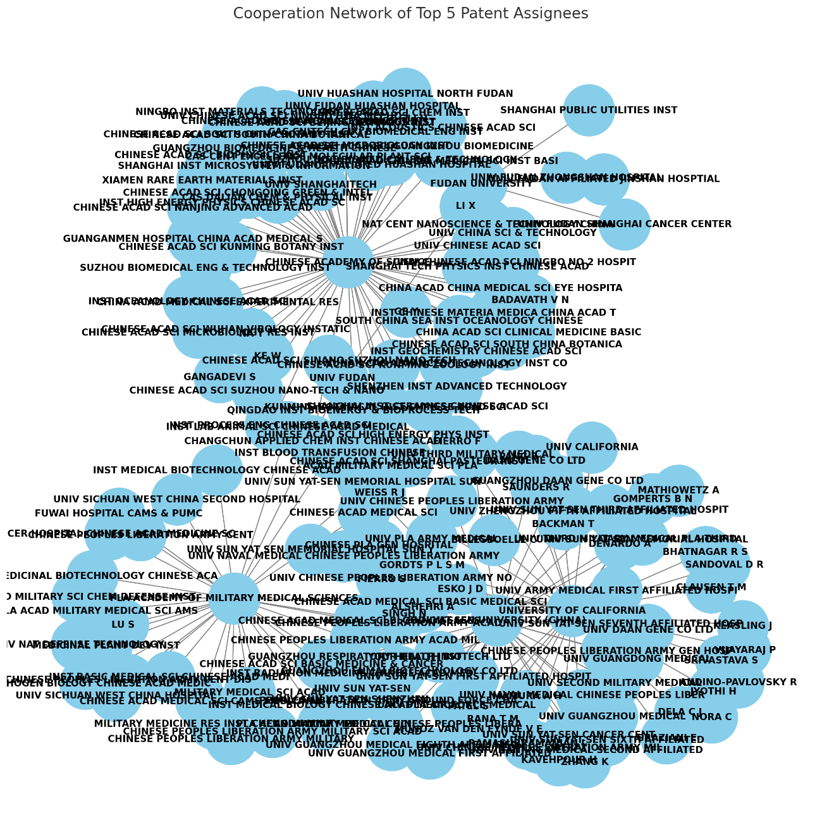
Figure 7: Collaboration network analysis

2 Evaluation of the Impact of Higher Education Institutions (HEIs):
With the standardized database, it is possible to assess the impact of HEIs on technological innovation, which involves counting patents assigned to these institutions. Moreover, the classification of entities according to Open Innovation Theory allows analyses to be segmented and focused specifically on the contributions of HEIs, highlighting their importance within the innovation ecosystem.

An experimental analysis of the standardized database revealed that the Chinese Academy of Sciences leads the combined impact indicators of patents, domain influence, and strategic importance. The PLA Academy of Military Medical Sciences and the University of California also stand out across all indicators. Fudan University and Sun Yat-sen University follow with relevant, though comparatively lower, performance levels (Figure 8).
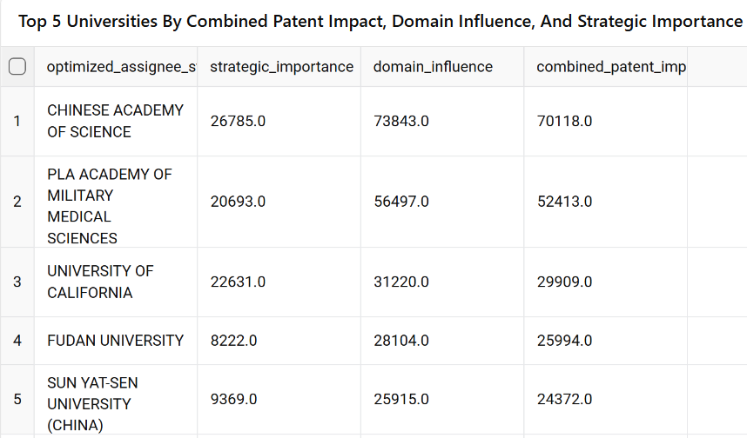
Figure 8: Impact of higher education institutions on technological innovation

- Competitiveness Studies Among Institutions and Companies:
Through standardization, it becomes possible to compare the number of patents and the nature of innovations among different companies within the same sector. Among the various possibilities, this analysis can reveal which companies are leaders in specific technological areas. An experimental analysis of the standardized database showed that Pfizer Inc. leads in the number of patents and demonstrates high levels of domain influence and combined impact. Venus Medtech (Hangzhou) Inc. stands out with a smaller number of patents but achieves the highest levels of domain influence and combined impact among the companies analyzed. Federal State Budgetary Institute and Regeneron Pharmaceuticals Inc. also hold significant patent numbers and relevant impact metrics, while Gilead Sciences Inc. maintains a competitive position across all indicators (Figure 9).

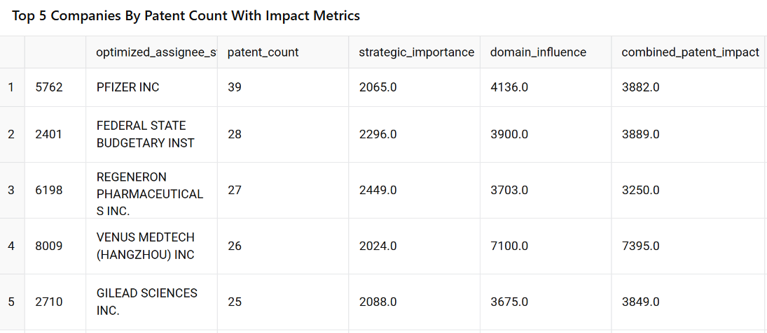
Figure 9: Competitiveness among companies and institutions
- Impact of Standardization on Data Quality and Usability: Data standardization is a fundamental process for improving the quality and usability of information used in research and analysis. It ensures data consistency, accuracy, and integrity, facilitates integration with other sources, and promotes greater study reproducibility. The main impacts of standardization on data quality and usability are detailed below.

  - Improved data consistency:Data standardization significantly reduced the number of duplicates and inconsistencies in entity names, resulting in cleaner and more reliable data. This was crucial to ensure the integrity of subsequent analyses. In this case, reducing 15,065 entity names to 14,721 unique entities demonstrated effective duplicate elimination.
  - Easier data integration and reuse:The creation of unique identifiers and entity classification facilitated database integration with other data sources and its reuse by various researchers. The unique identifiers eliminated ambiguities, enabling more accurate and reliable comparisons. This promoted collaboration and the execution of comparative analyses. The variable dictionary made available in this study, for instance, allowed other researchers to quickly understand the data structure and apply it in their own studies.
  - Enhanced data analysis:The organized and standardized structure of the data enabled more robust and detailed analyses, facilitating the identification of patterns and trends. This is particularly important for studies of collaboration and innovation networks. For example, the new column containing standardized names and identifiers allowed a clear visualization of connections among entities, enriching collaboration network analyses.
  - Increased reproducibility:The detailed documentation of standardization processes, along with the availability of scripts and the variable dictionary, greatly facilitates study reproducibility. These resources allow other researchers to reproduce results consistently and reliably. Moreover, the use of Jupyter Notebook to document the process ensured transparency and easy replication of all steps, promoting greater methodological rigor in subsequent research.

5 Discussion and conclusions
Database standardization for patent analysis remains a constant challenge in intellectual property research. This study demonstrated the application of a protocol to the Derwent database, significantly improving data quality by eliminating duplicates and making the dataset more consistent and organized for multiple types of analyses. Key contributions included the introduction of unique identifiers and the classification of entities according to Open Innovation Theory, enhancing the analysis and understanding of collaboration and innovation networks.
Understanding the processes and identifying ways to streamline them is essential. In the context of data analysis for open innovation—particularly during the COVID-19 pandemic—this approach contributes to identifying methods for fostering effective collaborations in the pursuit of technological solutions. The proposed methodology can and should be replicated in other crisis contexts.
Although the data standardization was effectively applied, it is important to note the challenge of identifying duplicates among entity names due to the lack of unique identifiers. Furthermore, the exclusion of 98 records may have resulted in partial loss of potentially relevant information. Therefore, future studies are encouraged to implement advanced machine learning techniques to detect duplicates and facilitate the inclusion of metadata that enhances entity identification.

References
Abbas, A., Zhang, L., & Khan, S. U. (2014). A literature review on the state-of-the-art in patent analysis. World Patent Information, 37, 3–13. https://doi.org/10.1016/J.WPI.2013.12.006
Abraham, B. P., & Moitra, S. D. (2001). Innovation assessment through patent analysis. Technovation, 21(4), 245–252. https://doi.org/10.1016/S0166-4972(00)00040-7
Batini, C., & Scannapieco, M. (2016). Data and information quality. Cham, Switzerland: Springer International Publishing, 63. https://link.springer.com/book/10.1007/978-3-319-24106-7
Biancolella, M., Colona, V. L., Luzzatto, L., Watt, J. L., Mattiuz, G., Conticello, S. G., Kaminski, N., Mehrian-Shai, R., Ko, A. I., Gonsalves, G. S., Vasiliou, V., Novelli, G., & Reichardt, J. K. V. (2023). COVID-19 annual update: a narrative review. Human Genomics 2023 17:1, 17(1), 1–14. https://doi.org/10.1186/S40246-023-00515-2
BitLaw. (2024). 301 Ownership/Assignability of Patents and Applications. Manual of Patent Examining Procedure. https://www.bitlaw.com/source/mpep/301.html
Borgatti, S. P., Mehra, A., Brass, D. J., & Labianca, G. (2009). Network Analysis in the Social Sciences. Science, 323(5916), 892–895.
Burgy, A. L., & Berkowitz, J. A. (2013). To File or Not to File As An Applicant-Assignee: That Is the Question. Finnegan. https://www.finnegan.com/en/insights/blogs/prosecution-first/to-file-or-not-to-file-as-an-applicant-assignee-that-is-the-question.html
Cammarano, A., Michelino, F., & Caputo, M. (2022). Extracting firms’ R&D processes from patent data to study inbound and coupled open innovation. Creativity and Innovation Management, 31(2), 322–339. https://doi.org/10.1111/CAIM.12495
Capone, F., & Innocenti, N. (2020). Open innovation and network dynamics. An analysis of openness of co-patenting collaborations in Florence, Italy. Competitiveness Review, 30(4), 379–396. https://doi.org/10.1108/CR-10-2019-0101/FULL/PDF
Chesbrough, H. (2020). To recover faster from Covid-19, open up: Managerial implications from an open innovation perspective. Industrial Marketing Management, 88, 410–413. https://doi.org/10.1016/J.INDMARMAN.2020.04.010
Chesbrough, H. W. (2006). The era of open innovation. In David, Mayle (Ed.). Managing Innovation and Change. 3th ed. London: Sage. https://www.google.com.br/books/edition/Managing_Innovation_and_Change/eVptX3b_sKgC?hl=pt-BR&gbpv=1&dq=Chesbrough,+H.+W.+(2003).+The+era+of+open+innovation.+MIT+Sloan+Management,+44(3),+35-41.+artigo&pg=PA127&printsec=frontcover
Clarivate. (2023). Derwent Innovation. Recuperado de https://clarivate.com/products/derwent-innovation/
Doan, A., Halevy, A., & Ives, Z. (2012). Principles of data integration. Elsevier. https://shop.elsevier.com/books/principles-of-data-integration/doan/978-0-12-416044-6
Ferraz, R. R. N., Quoniam, L., Reymond, D., & Nigro, C. A. (2014, September). Exemplo de uso gratuito do OPS (Open Patent Service) para educação e informação em patentes por meio da utilização da ferramenta computacional Patent2net. In XXXVIII Encontro da ANPAD (EnANPAD). https://archivesic.ccsd.cnrs.fr/sic_01809895
Dodgson, M, Gann, D., & Salter, A. (2006). The role of technology in the shift towards open innovation: the case of Procter & Gamble. R & D Management, 36(3), 333-346. http://dx.doi.org/10.1111/j.1467-9310.2006.00429.x
Hirata, D., Kniess, C. T., Cortese, T. T. P., & Quoniam, L. (2015). O uso de informações patentárias para a valorização de resíduos industriais: o caso do lodo de tratamento de esgoto doméstico. Revista de Ciências da Administração, 17(43), 55-71. https://www.redalyc.org/articulo.oa?id=273543309005
Holgersson, M., & Granstrand, O. (2017). Patenting motives, technology strategies, and open innovation. Management Decision, 55(6), 1265–1284. https://doi.org/10.1108/MD-04-2016-0233/FULL/PDF
Janavi, E., & Emami, M. (2020). A co-citation study of information security patents in the USPTO database. Library Hi Tech, 39(4), 936–950. https://doi.org/10.1108/LHT-05-2020-0111/FULL/PDF
Jialu, S., Zhiqiang, M., Binxin, Z., Haoyang, X., Fredrick Oteng, A., & Hu, W. (2021). Collaborative Innovation Network, Knowledge Base, and Technological Innovation Performance-Thinking in Response to COVID-19. Frontiers in Psychology, 12, 648276. https://doi.org/10.3389/FPSYG.2021.648276/BIBTEX
Kluyver, Thomas, Ragan-Kelley, Benjamin, Pérez, Fernando, Granger, Brian, Bussonnier, Matthias, Frederic, Jonathan, Kelley, Kyle, Hamrick, Jessica, Grout, Jason, Corlay, Sylvain, Ivanov, Paul, Avila, Damián, Abdalla, Safia, Willing, Carol & Jupyter development team, (2016). Jupyter Notebooks: a publishing format for reproducible computational workflows. https://ui.adsabs.harvard.edu/abs/2016ppap.book...87K/abstract
Liu, K., Zhang, X., Hu, Y., Chen, W., Kong, X., Yao, P., Cong, J., Zuo, H., Wang, J., Li, X., & Wei, B. (2022). What, where, when and how of COVID-19 patents landscape: A bibliometrics review. Frontiers in Medicine, 9, 925369. https://doi.org/10.3389/FMED.2022.925369/BIBTEX
Loizides, Fernando & Schmidt, Birgit (Ed.). (2016). Positioning and power in academic publishing: Players, Agents and agendas. Amsterdan: IOS Press. p. 87-90. doi:10.3233/978-1-61499-649-1-87.

Masiakowski, P., & Wang, S. (2013). Integration of software tools in patent analysis. World Patent Information, 35(2), 97-104. https://www.researchgate.net/publication/271880558_Integration_of_software_tools_in_patent_analysis
McKinney, W. (2010). Data Structures for Statistical Computing in Python. In Proceedings of the 9th Python in Science Conference, Austin, 28 June-3 July 2010, 56-61.
https://doi.org/10.25080/Majora-92bf1922-00a
Noh, H., & Lee, S. (2020). What constitutes a promising technology in the era of open innovation? An investigation of patent potential from multiple perspectives. Technological Forecasting and Social Change, 157. https://doi.org/10.1016/J.TECHFORE.2020.120046
Onyango, G., & Ondiek, J. O. (2022). Open innovation during the COVID‐19 pandemic policy responses in South Africa and Kenya. Politics & Policy (Statesboro, Ga.), 50(5), 1008–1031. https://doi.org/10.1111/POLP.12490
Patra, S. P. (2023). Role of open innovation and patents on strategic decision making. The Journal of World Intellectual Property, 26(3), 381–413. https://doi.org/10.1111/JWIP.12277
Patrucco, A. S., Trabucchi, D., Frattini, F., & Lynch, J. (2022). The impact of Covid-19 on innovation policies promoting Open Innovation. R and D Management, 52(2), 273–293. https://doi.org/10.1111/RADM.12495
Paskhaver, B. (2021). Pandas in action. Nova York: Manning Publications, 2021. https://learning.oreilly.com/library/view/pandas-in-action/9781617297434/OEBPS/Text/title.htm
Perkel, J. M. (2018). Why Jupyter is data scientists’ computational notebook of choice. Nature, 563:145–146. https://www.nature.com/articles/d41586-018-07196-1
Perkel, J. M. (2021). Reactive, reproducible, collaborative: computational notebooks evolve. Nature, 593:156–157. 10.1038/d41586-021-01174-w
Python Software Foundation. (2023). Python 3.10. Python Software Foundation. https://www.python.org/downloads/
Pimentel, J. F., Murta, L., Braganholo, V., & Freire, J. (2019). A large-scale study about quality and reproducibility of jupyter notebooks. In IEEE 6th International Conference on Mining Software Repositories (MSR). 507-517. 10.1109/MSR.2019.00077.
Pimentel, J. F., Oliveira, G. P., Silva, M. O., Seufitelli, D. B., & Moro, M. M. (2021). Ciência de Dados com Reprodutibilidade usando Jupyter. In.: Andrade, A. M. S. & Wazlawick, R. S. Jornada de Atualização em Informática. 10.5753/sbc.6757.3.1.
Quoniam, L., Kniess, C. T., & MAZIERI, M. R. (2014). A patente como objeto de pesquisa em Ciências da Informação e Comunicação. Encontros Bibli: revista eletrônica de biblioteconomia e ciência da informação, 19(39), 243-268. https://www.redalyc.org/articulo.oa?id=14730602013
Ritto, A. P., de Araujo, A. L., de Carvalho, C. R. R., De Souza, H. P., Favaretto, P. M. e. S., Saboya, V. R. B., Garcia, M. L., Kulikowski, L. D., Kallás, E. G., Pereira, A. J. R., Cobello Junior, V., Silva, K. R., Abdalla, E. R. F., Segurado, A. A. C., Sabino, E. C., Ribeiro Junior, U., Francisco, R. P. V., Miethke-Morais, A., Levin, A. S. S., … Busatto Filho, G. (2024). Data-driven, cross-disciplinary collaboration: Lessons learned at the largest academic health center in Latin America during the COVID-19 pandemic. Frontiers in Public Health, 12.. https://doi.org/10.3389/FPUBH.2024.1369129/BIBTEX
Shen, H. (2014). Interactive notebooks: Sharing the code. Nature, 515(7525):151–152. https://www.nature.com/articles/515151a
Sperry, C., & Hammond, M. D. (2020). Procuring U.S. Patents without a Signed Assignment of Patent Rights. Mintz. https://www.mintz.com/insights-center/viewpoints/2231/2020-10-27-procuring-us-patents-without-signed-assignment-patent
Suh, Y., & Jeon, J. (2019). Monitoring patterns of open innovation using the patent-based brokerage analysis. Technological Forecasting and Social Change, 146, 595–605. https://doi.org/10.1016/J.TECHFORE.2018.01.037
Zhang, L., & Liu, Z. (2020). Research on technology prospect risk of high-tech projects based on patent analysis. Plos One, 15(10). https://doi.org/10.1371/JOURNAL.PONE.0240050
Zien, K. A., & Buckler, S. A. (2003). From experience dreams to market: Crafting a culture of innovation. Journal of Product Innovation Management, 14(4), 274-287. http://dx.doi.org/10.1016/S0737-6782(97)00029-5
Zoltan, J. Acs & Audretsch, D. B. (1989). Patents as a Measure of Innovative Activity. Kyklos, 42(2), 171–180. https://doi.org/10.1111/J.1467-6435.1989.TB00186.X

